Getting to the Core of RSI

Spring Summit 2026

Thursday, February, 19, 2026

Agenda
- Accreditation Update
- Warm Up
- RSI Breakdown
- Peers in Practice
- RSI Glow Up

Accreditation Update
- Accreditation Review of RSI
  - October 2025
  - Received core inquiry from ACCJC
- Response to Core Inquiry
  - Starting November 2025
  - Pulled a new sample and compiled evidence of RSI
  - Piloted internal peer reviews of RSI
  - Hosting CIL-based RSI professional development
- Next Steps
  - Site visit - February 24th
  - RSI syllabus statement
  - RSI rubric development
  - Final report coming in June 2026

Warm Up Discussion
Share an assignment or communication strategy that you regularly use to interact with your students.

Notes:

RSI Definition
Regular Substantive Interaction (RSI) means instructors monitor student participation and initiate substantive action and communication that facilitate teaching, learning, and assessing on a weekly basis.

Courses must include RSI from
- at least one Area per week and
- at least two Areas during the course.

RSI Quick Guide
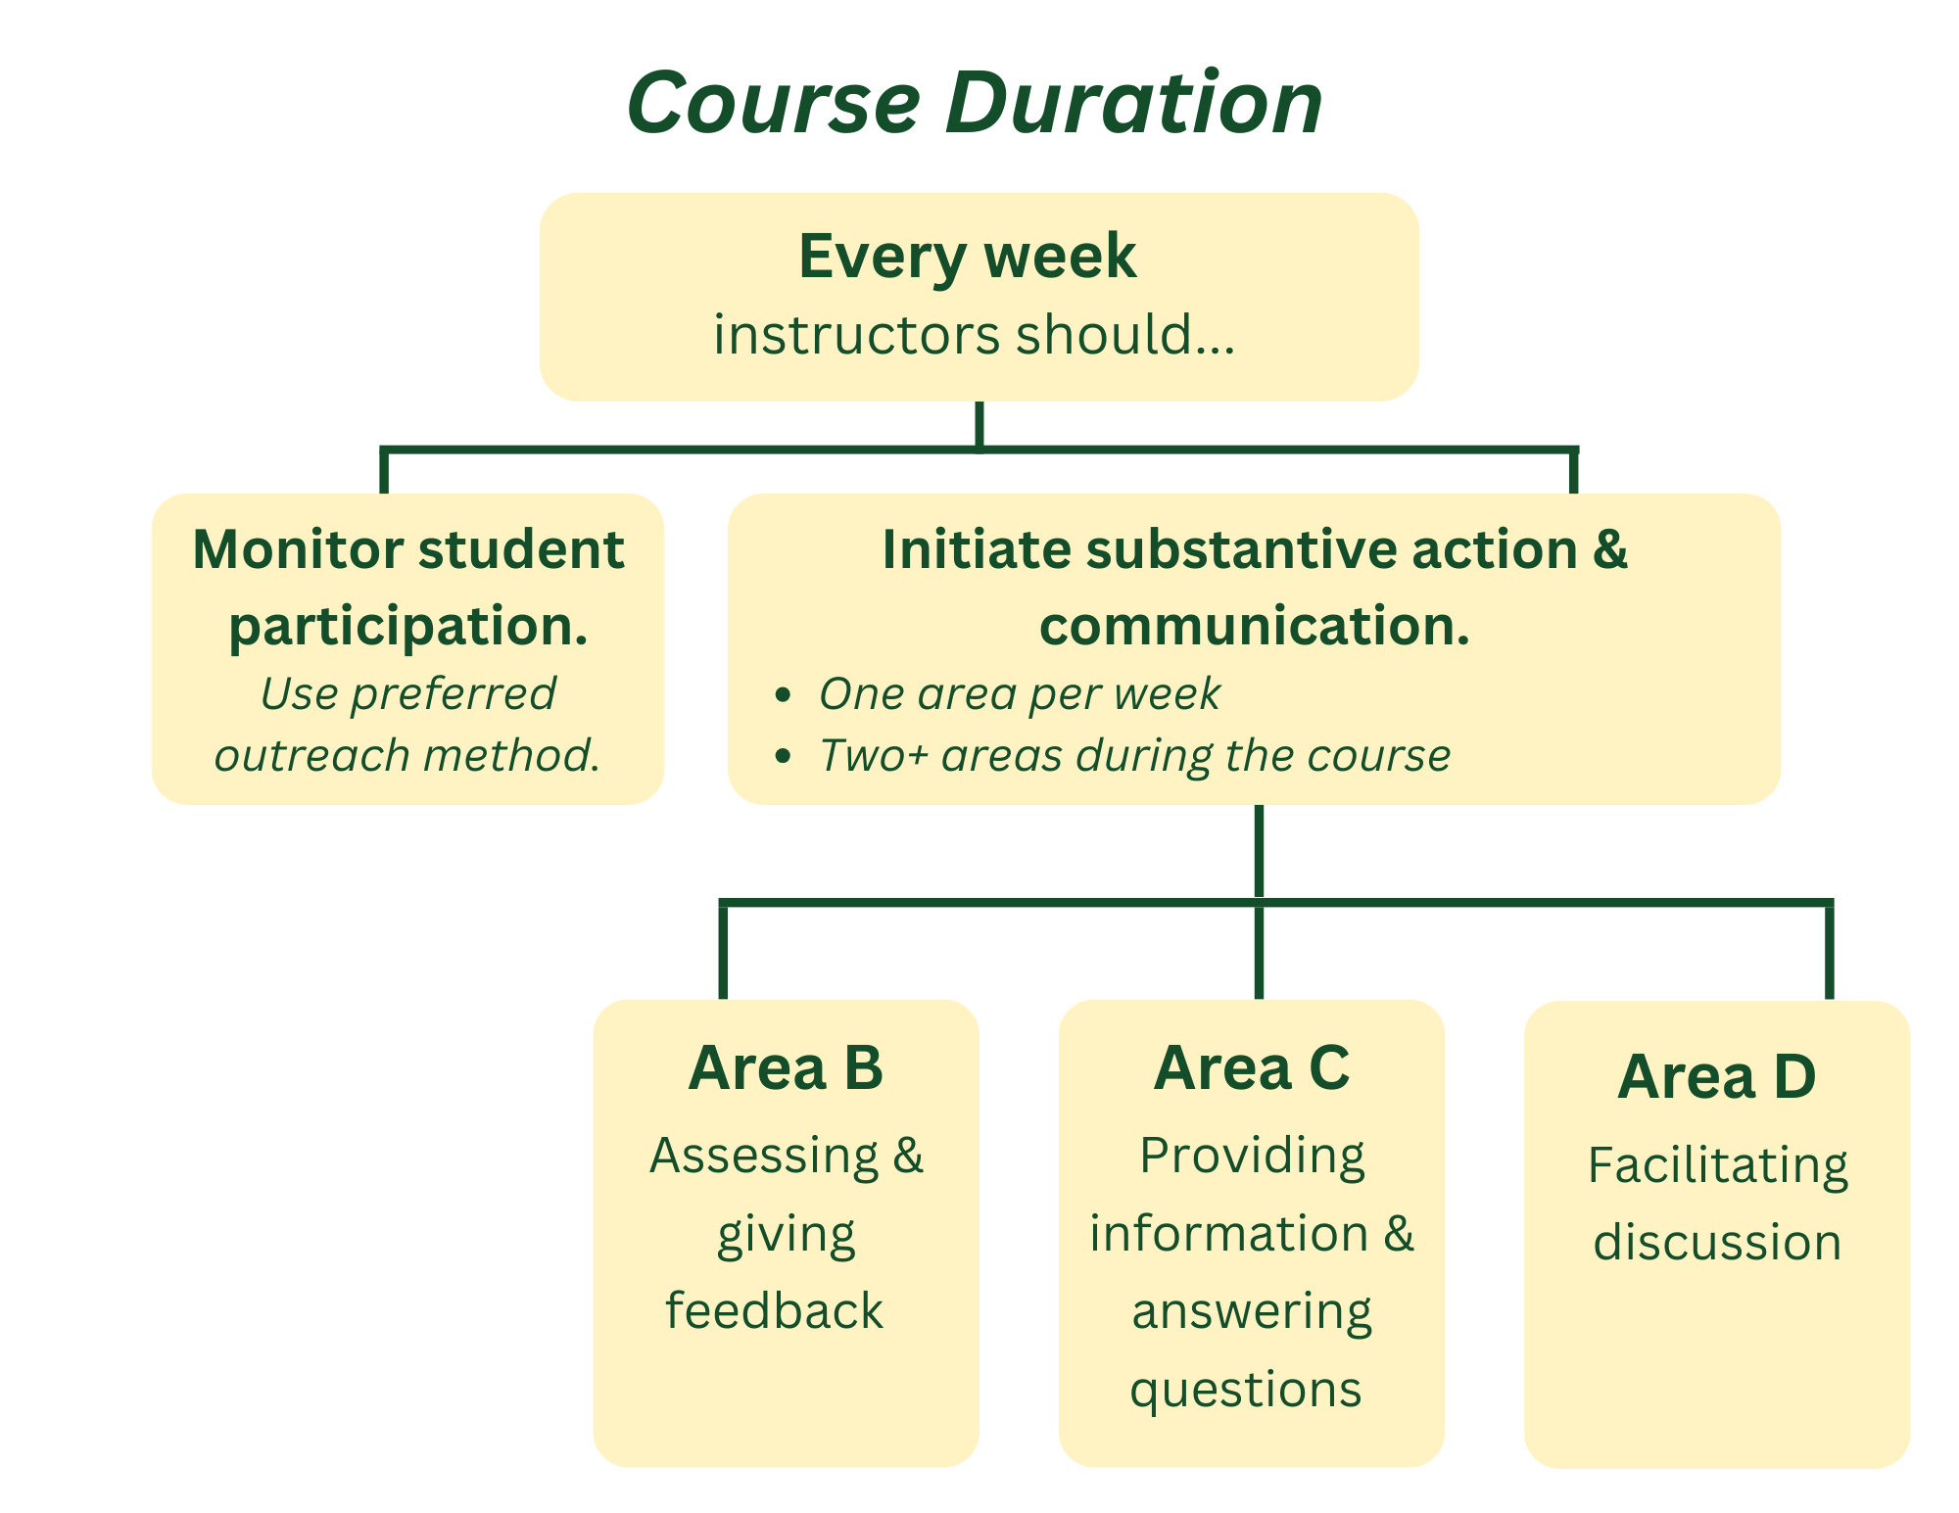
Notes:

RSI Areas
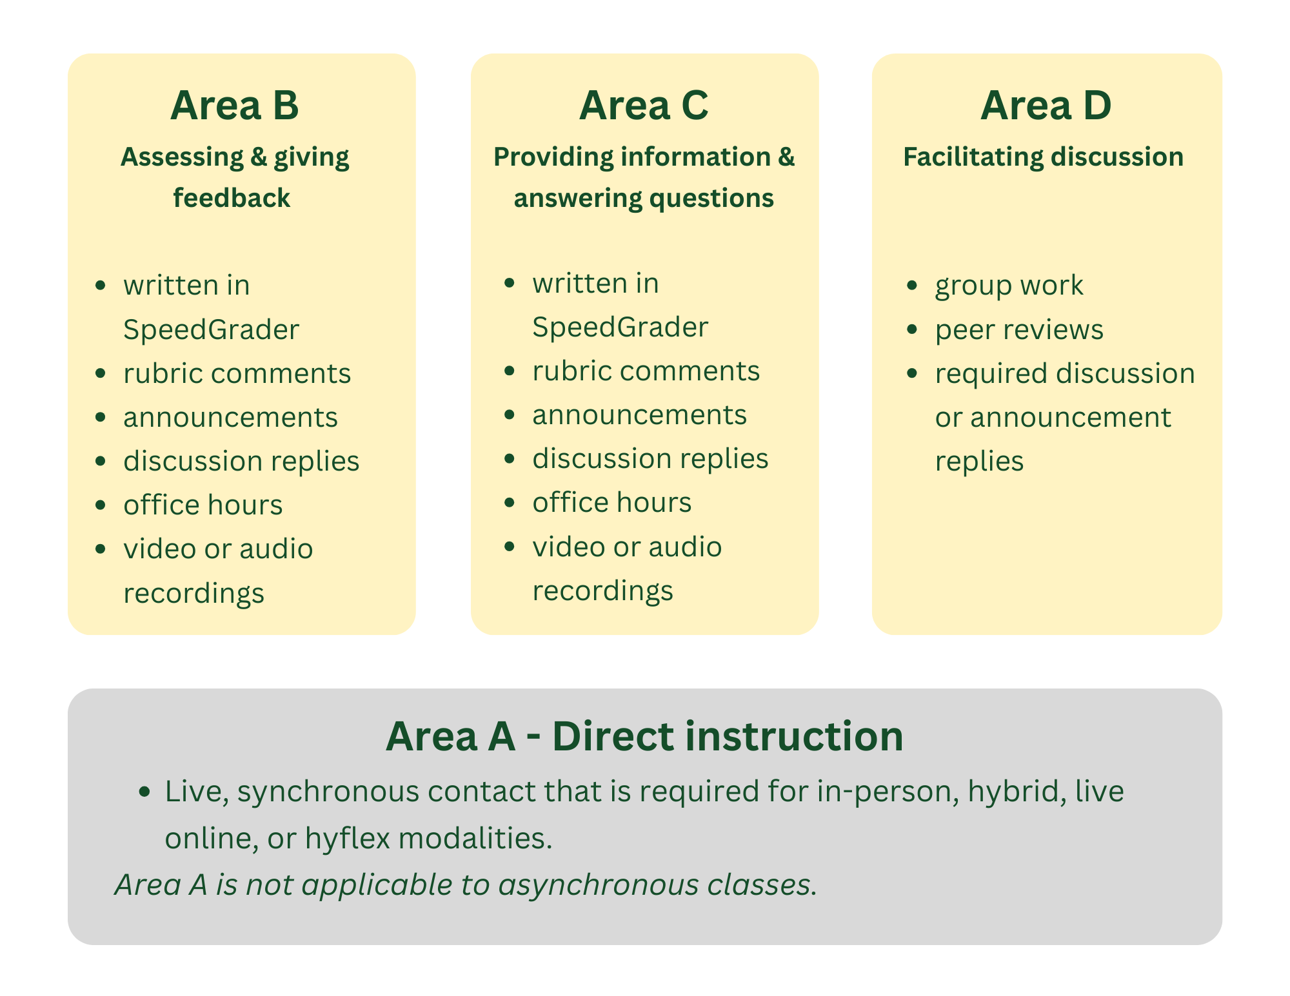

Notes:

RSI Inventory
Individually, complete the RSI Inventory on pages 4-5 of your packet.

RSI Area | I do this well. | I think I do this, and this is the specific location where it happens. | I do not do this, and/or I have a question about where or how to do this.
B: Assessing and Giving Feedback
- Written in SpeedGrader
- Rubric Comments
- Announcements
- Discussion Replies
- Office Hours
- Video or Audio Recordings
C: Providing Information and Answering Questions
- Written in SpeedGrader
- Rubric Comments
- Announcements
- Discussion Replies
- Office Hours
- Video or Audio Recordings
D: Facilitating Discussion
- Group Work
- Peer Reviews
- Required Discussion or Announcement Replies

Notes:

RSI: Peers in Practice
In your group, you will go to a station that features exemplars from RSI Areas B, C, and D.
Area B: Assessing and Giving Feedback
Area C: Providing Information and Answering Questions
Area D: Facilitating Discussion
Review the exemplars and take notes on page 6 of your packet.
- What are some practices in each RSI Area you would like to integrate into your classes?
- What is a question you have about a practice in this RSI Area?
Be specific and practical. Think about what this could look like in your own course/s, with your students, this semester.
Notes:
Area | Notes
B: Assessing and Giving Feedback
C: Providing Information and Answering Questions
D: Facilitating Discussion

Glow Up Activity: Strengthening RSI Practices
Now that you’ve explored strong exemplars, it’s time to “glow up” a practice.
Each group will see sample practices from RSI Areas B, C, or D on pages 7-9 of your packet. These examples intentionally fall short of RSI; they may adopt general best practices and appear to meet the category, but they could be much stronger in using RSI to support student engagement and learning.
Your task:
- Read the sample practice and note which RSI Area it represents: B, C, or D.
- As a group, brainstorm ways to enhance or “glow up” the practice with RSI actions that make it more effective, inclusive, and engaging.
- Capture your ideas in the graphic organizer.
Be ready to share your revisions!

Glow-Up | Area B: Assessing and Giving Feedback
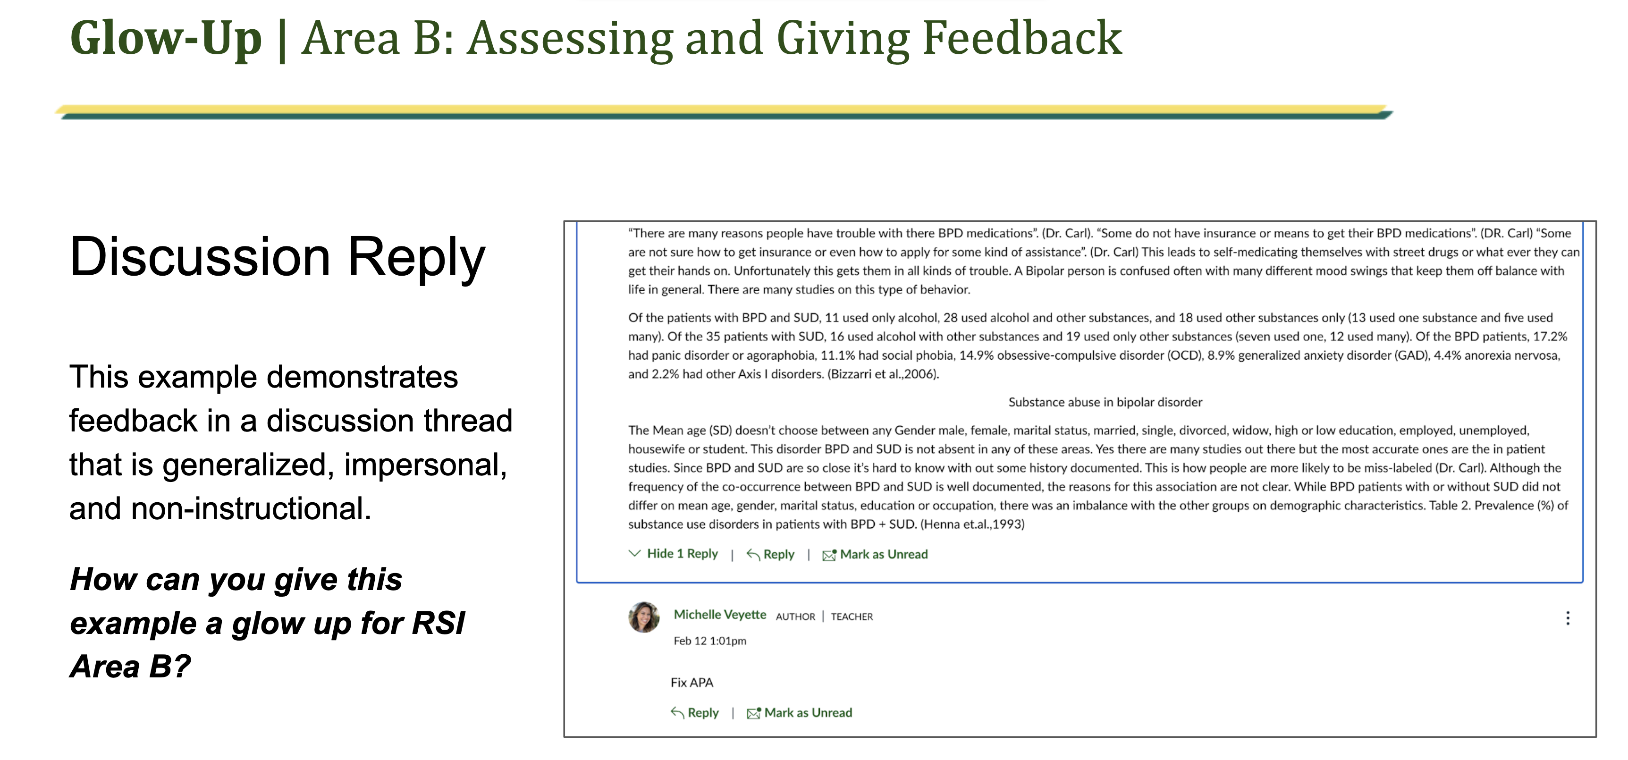
Notes:

Glow-Up | Area C: Providing Information and Answering Questions

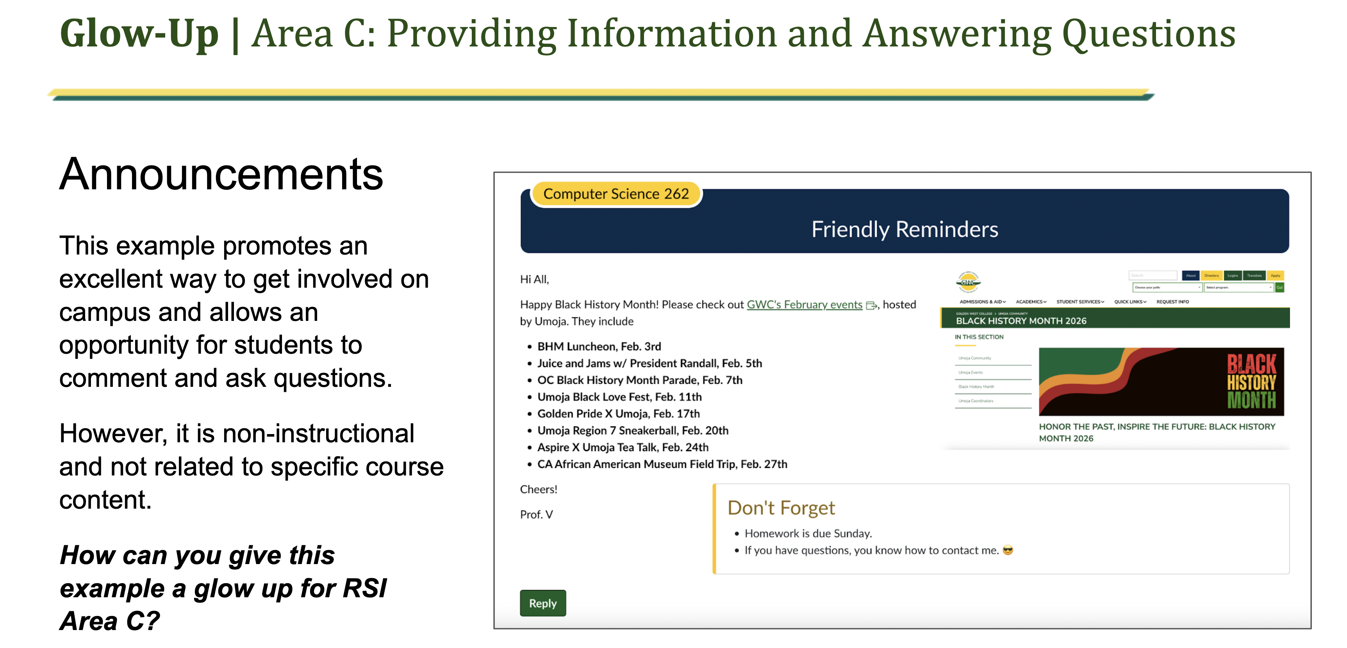
Notes:

Glow-Up | Area D: Facilitating Discussion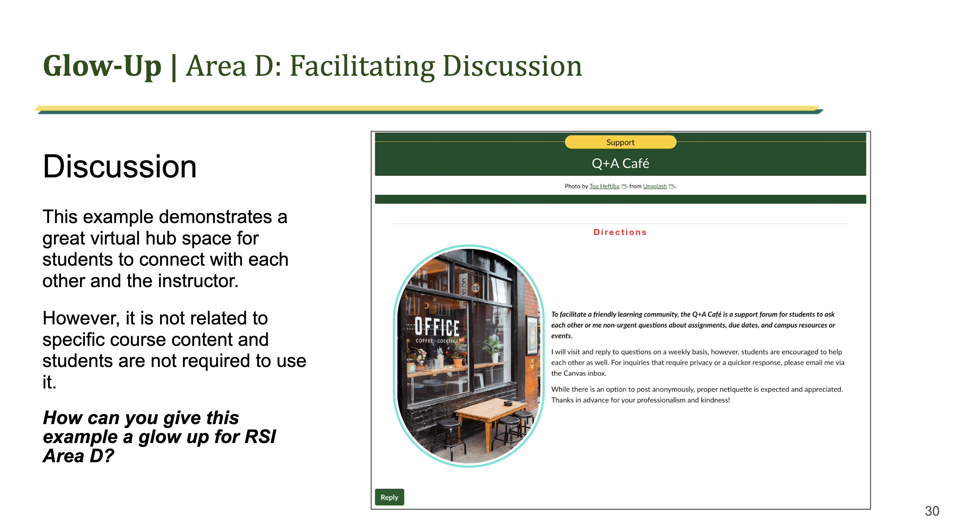
Notes:

Upcoming RSI Training at the CIL

Swing By for RSI Support
Friday, March 13th, 10 am - 12 pm

Save the Dates - Upcoming Sessions for RSI and POCR
Friday, April 17th, 1-3 pm
Friday, May 1st, 1-3 pm

Thank You!

Appendix A: Exemplars from Peers in Practice

Area B
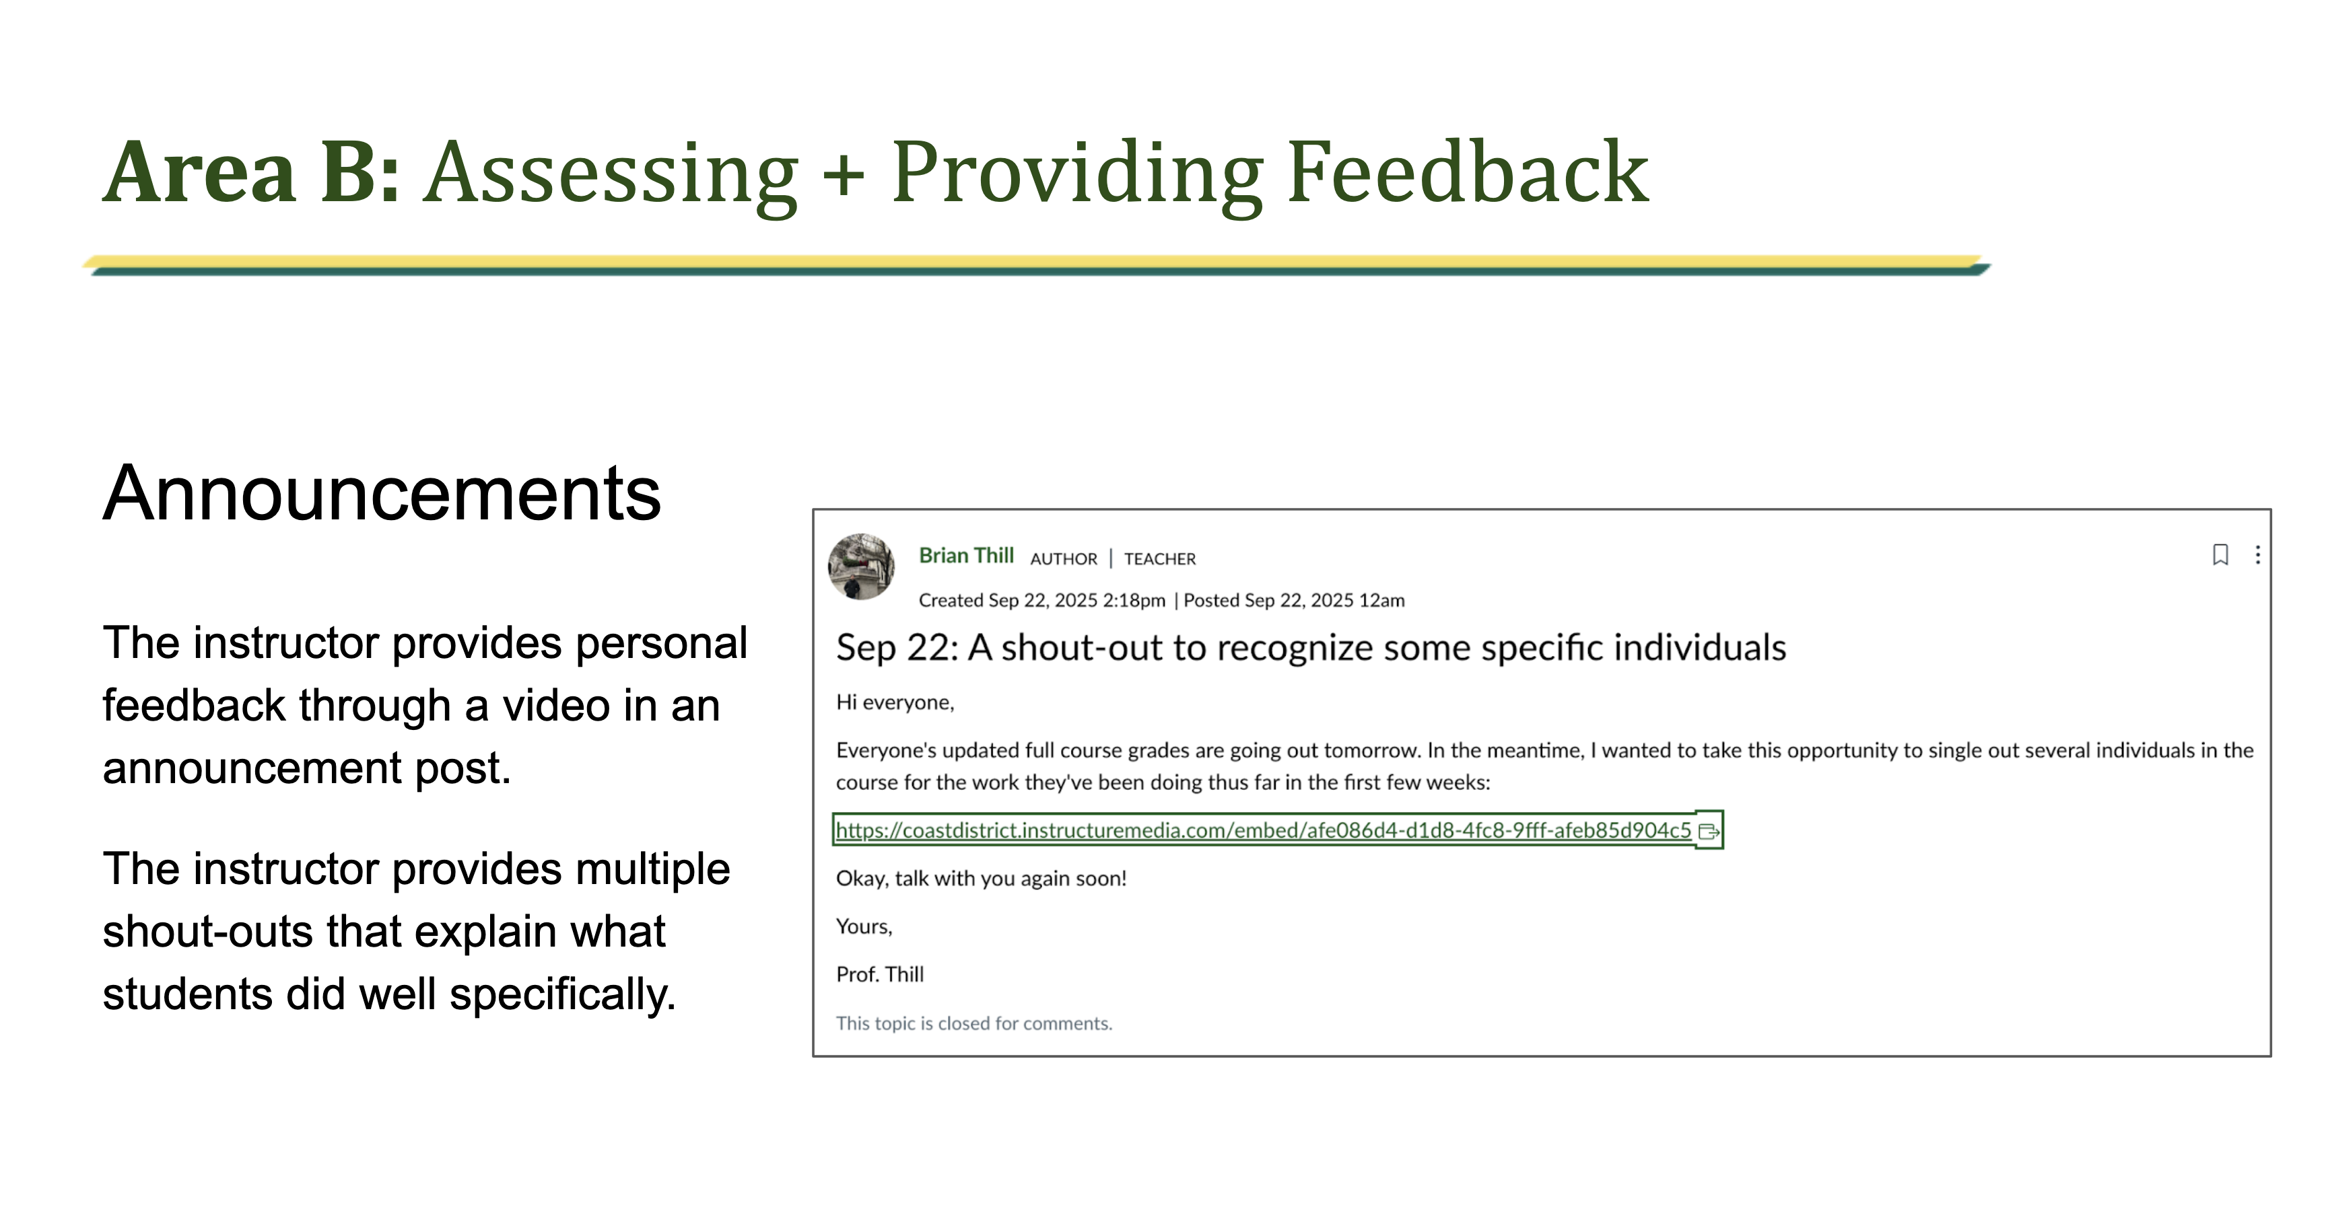
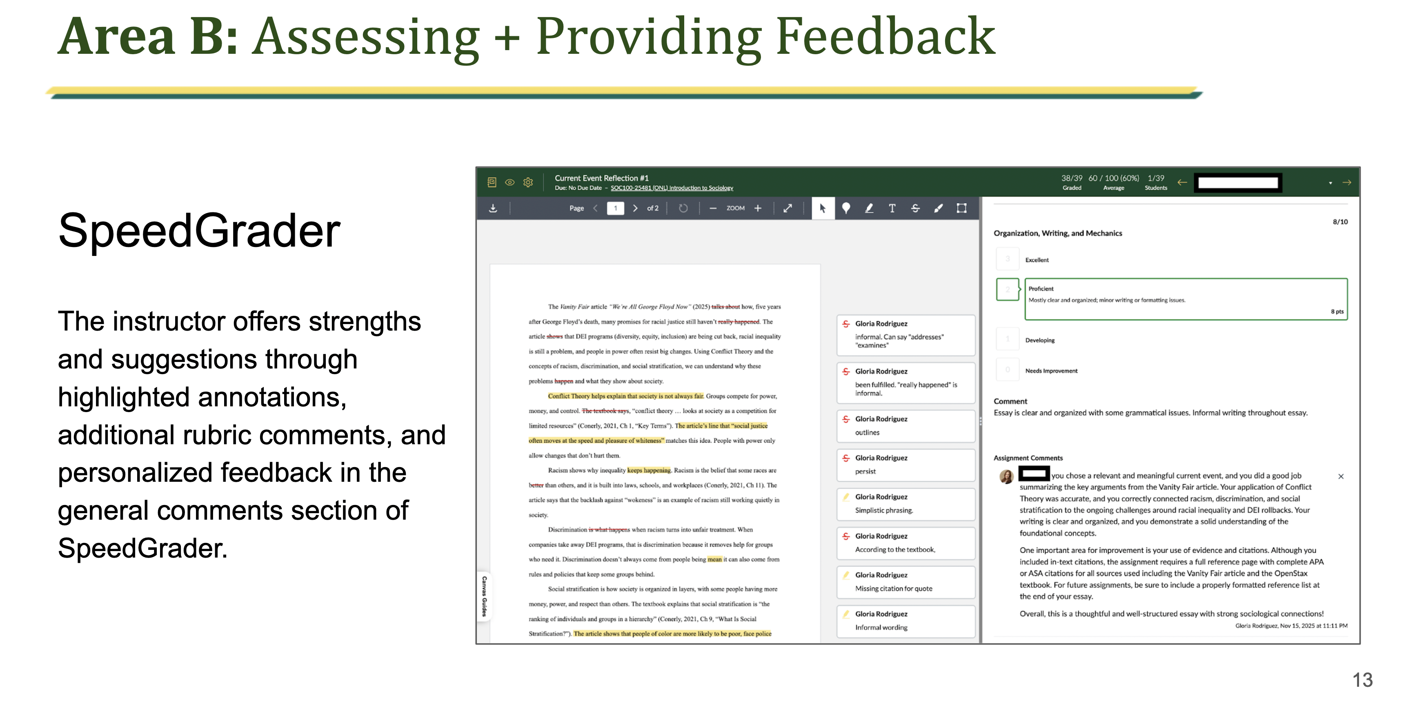
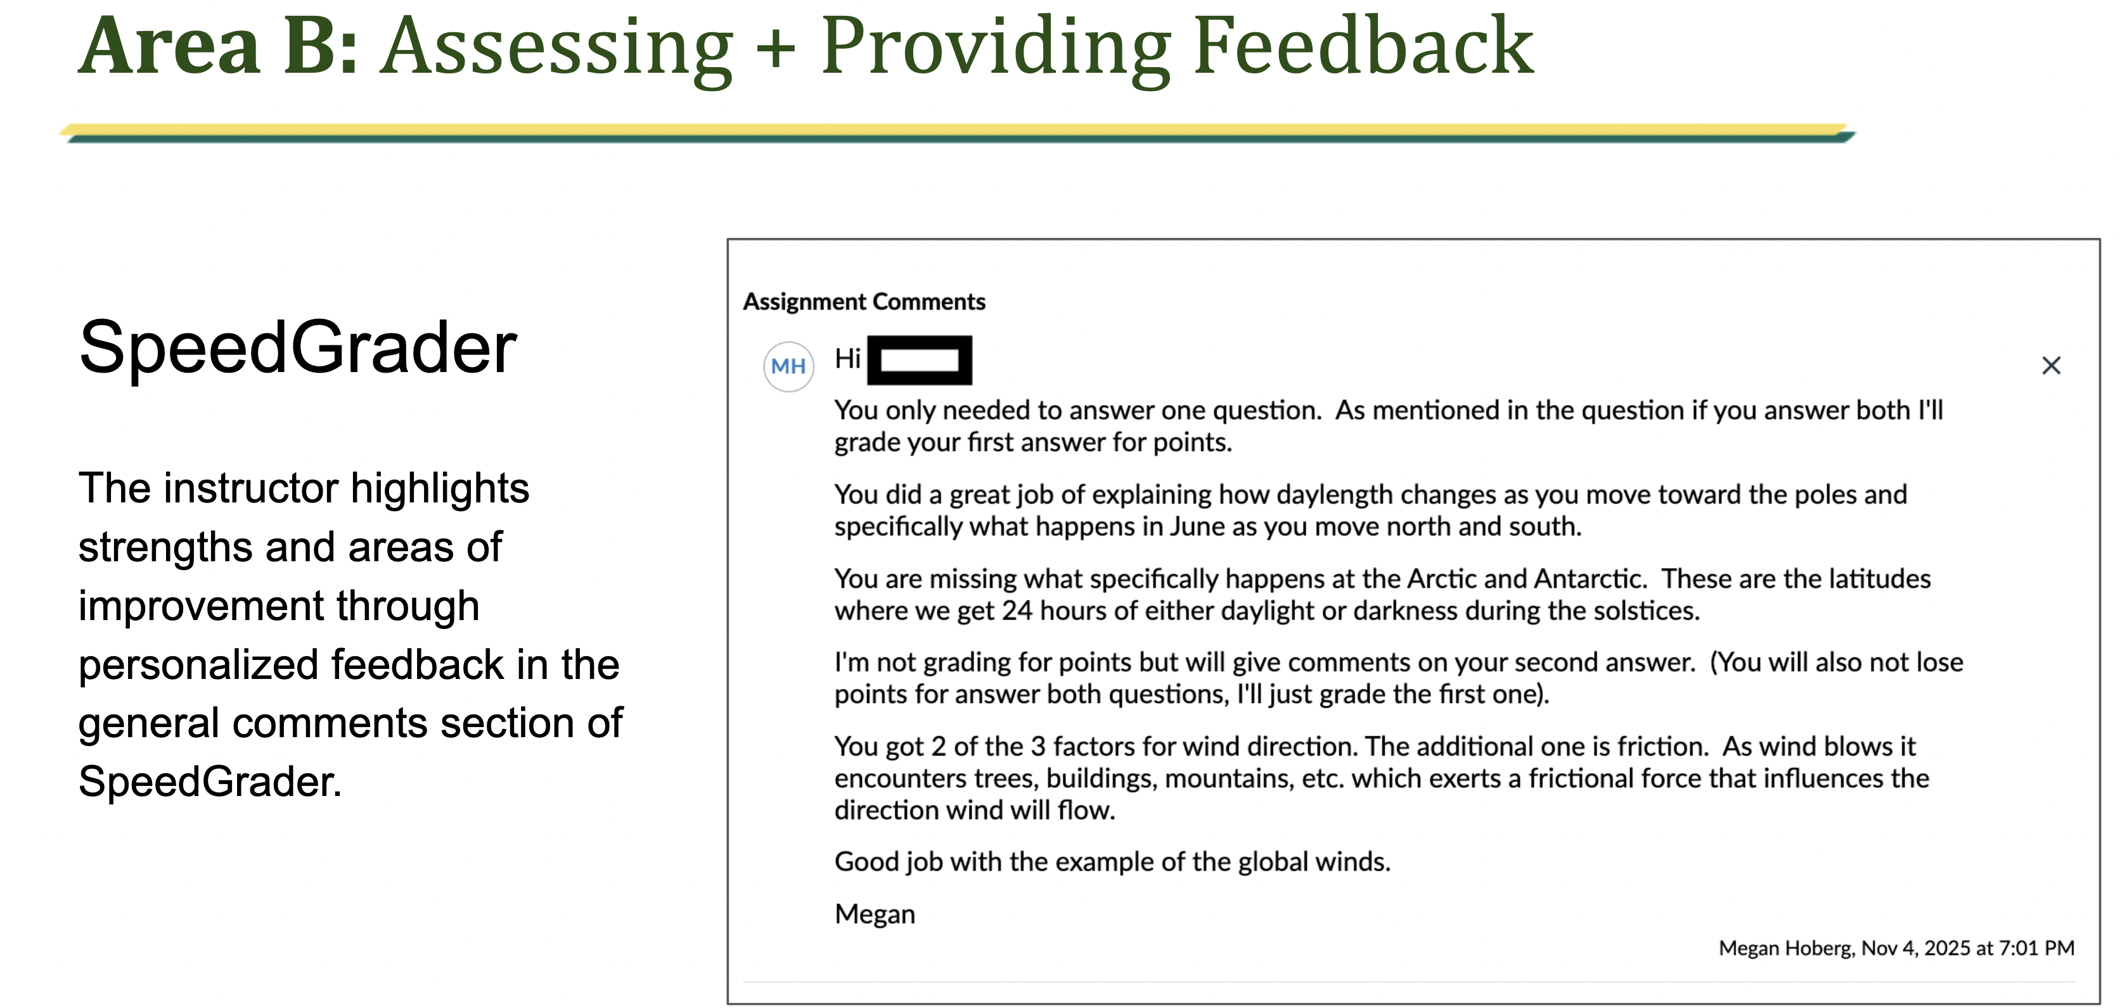

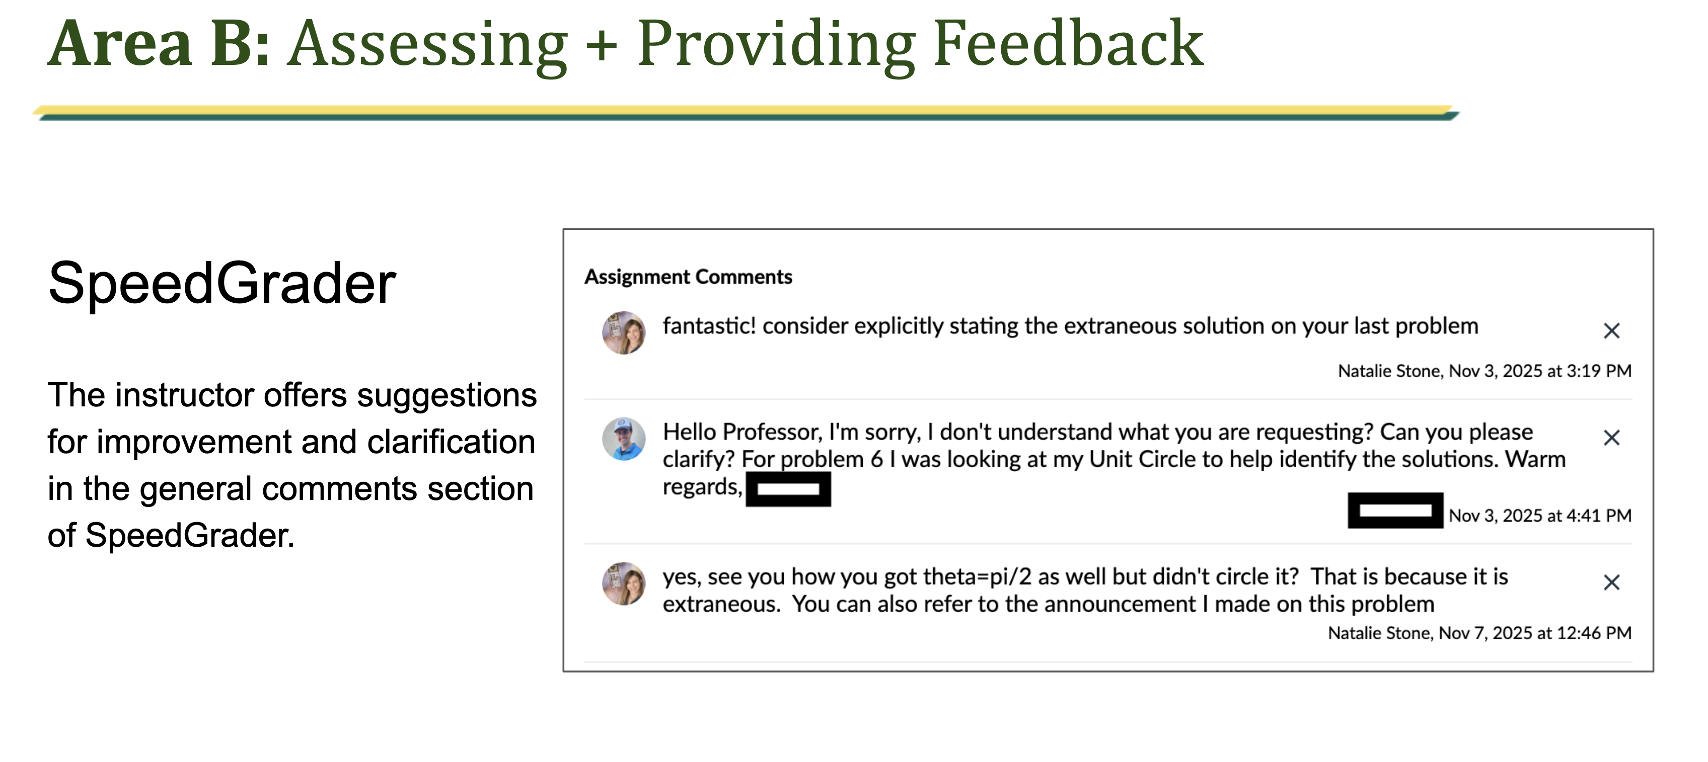
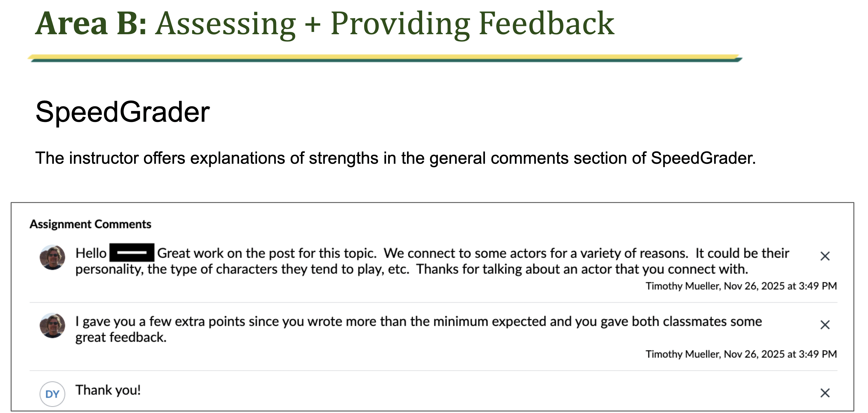

Area C
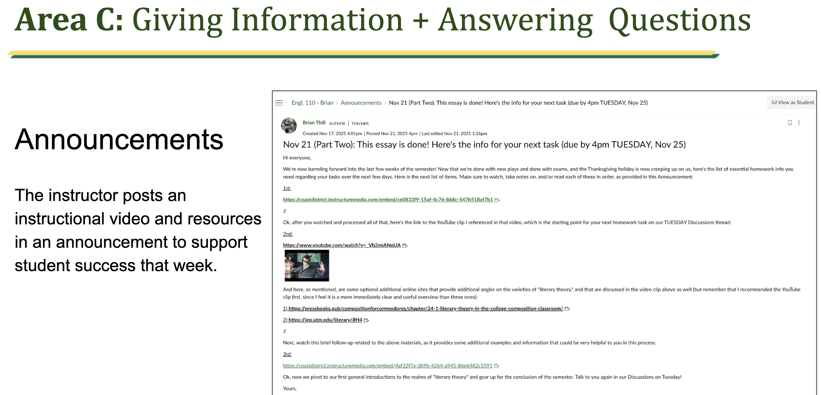
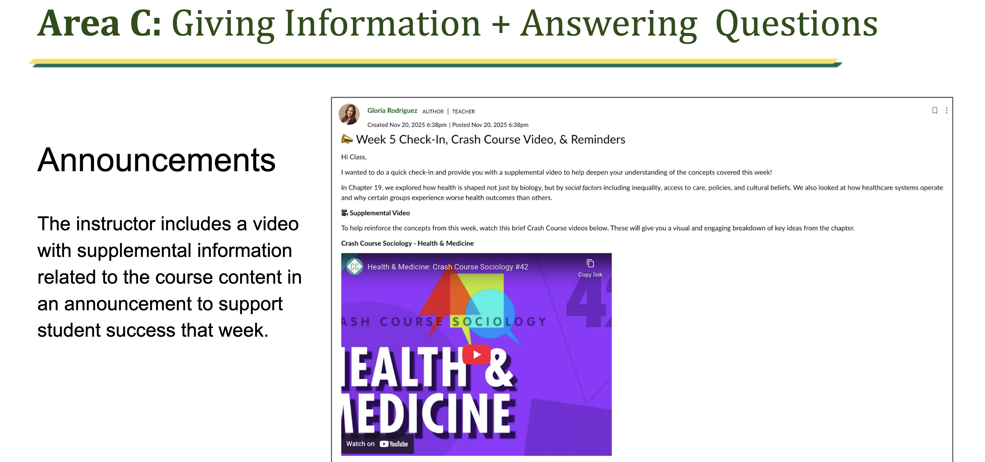

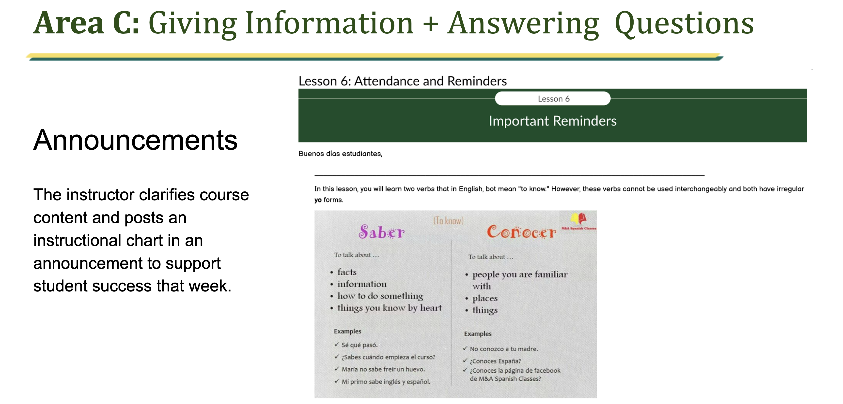

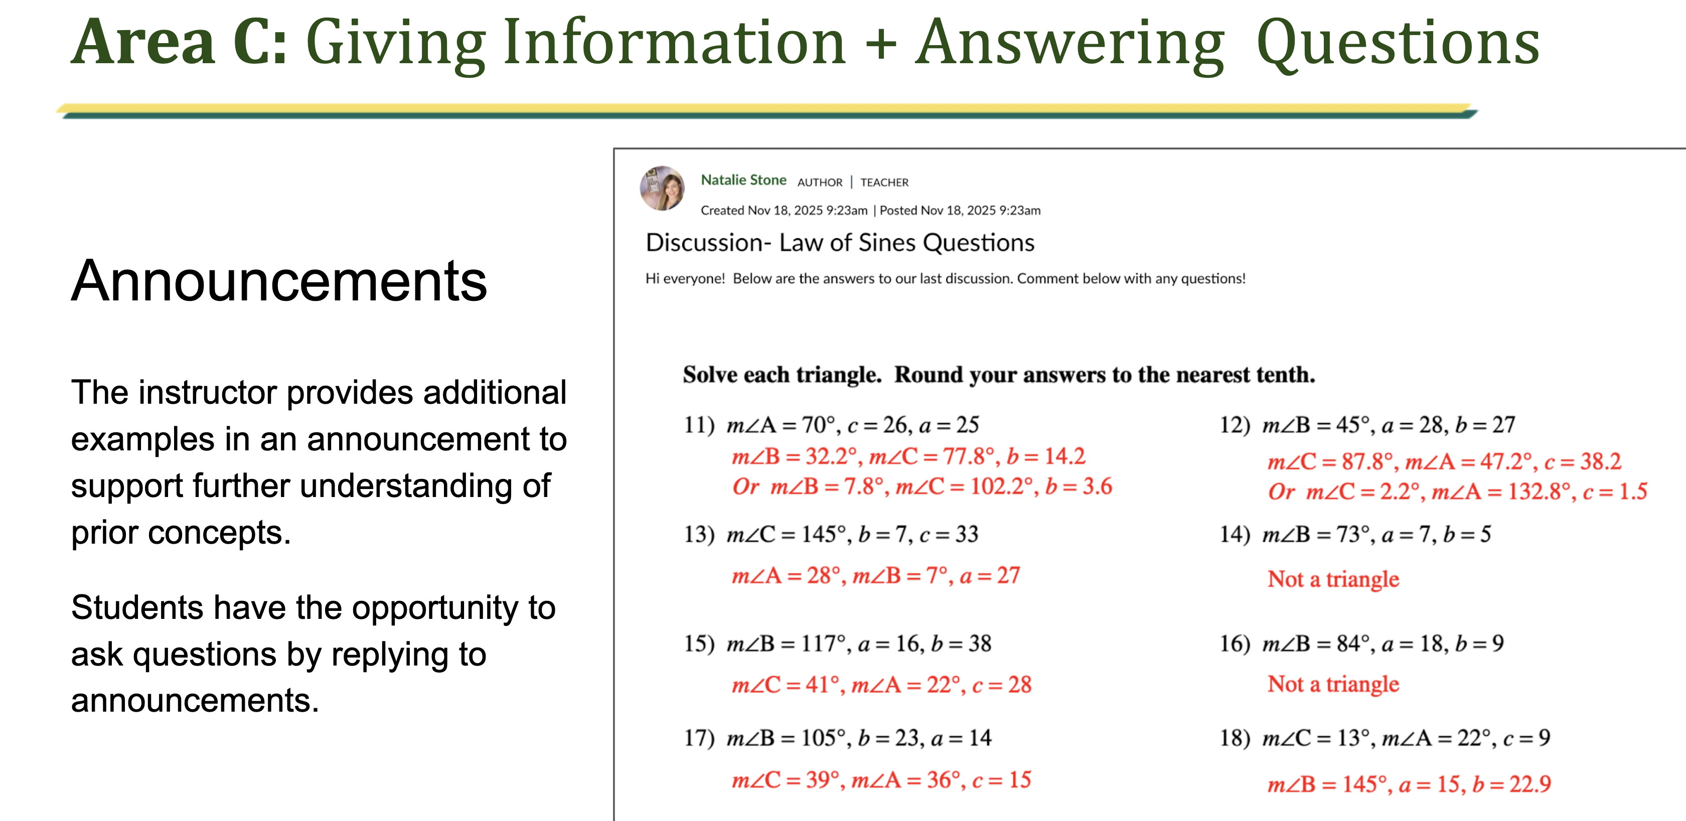

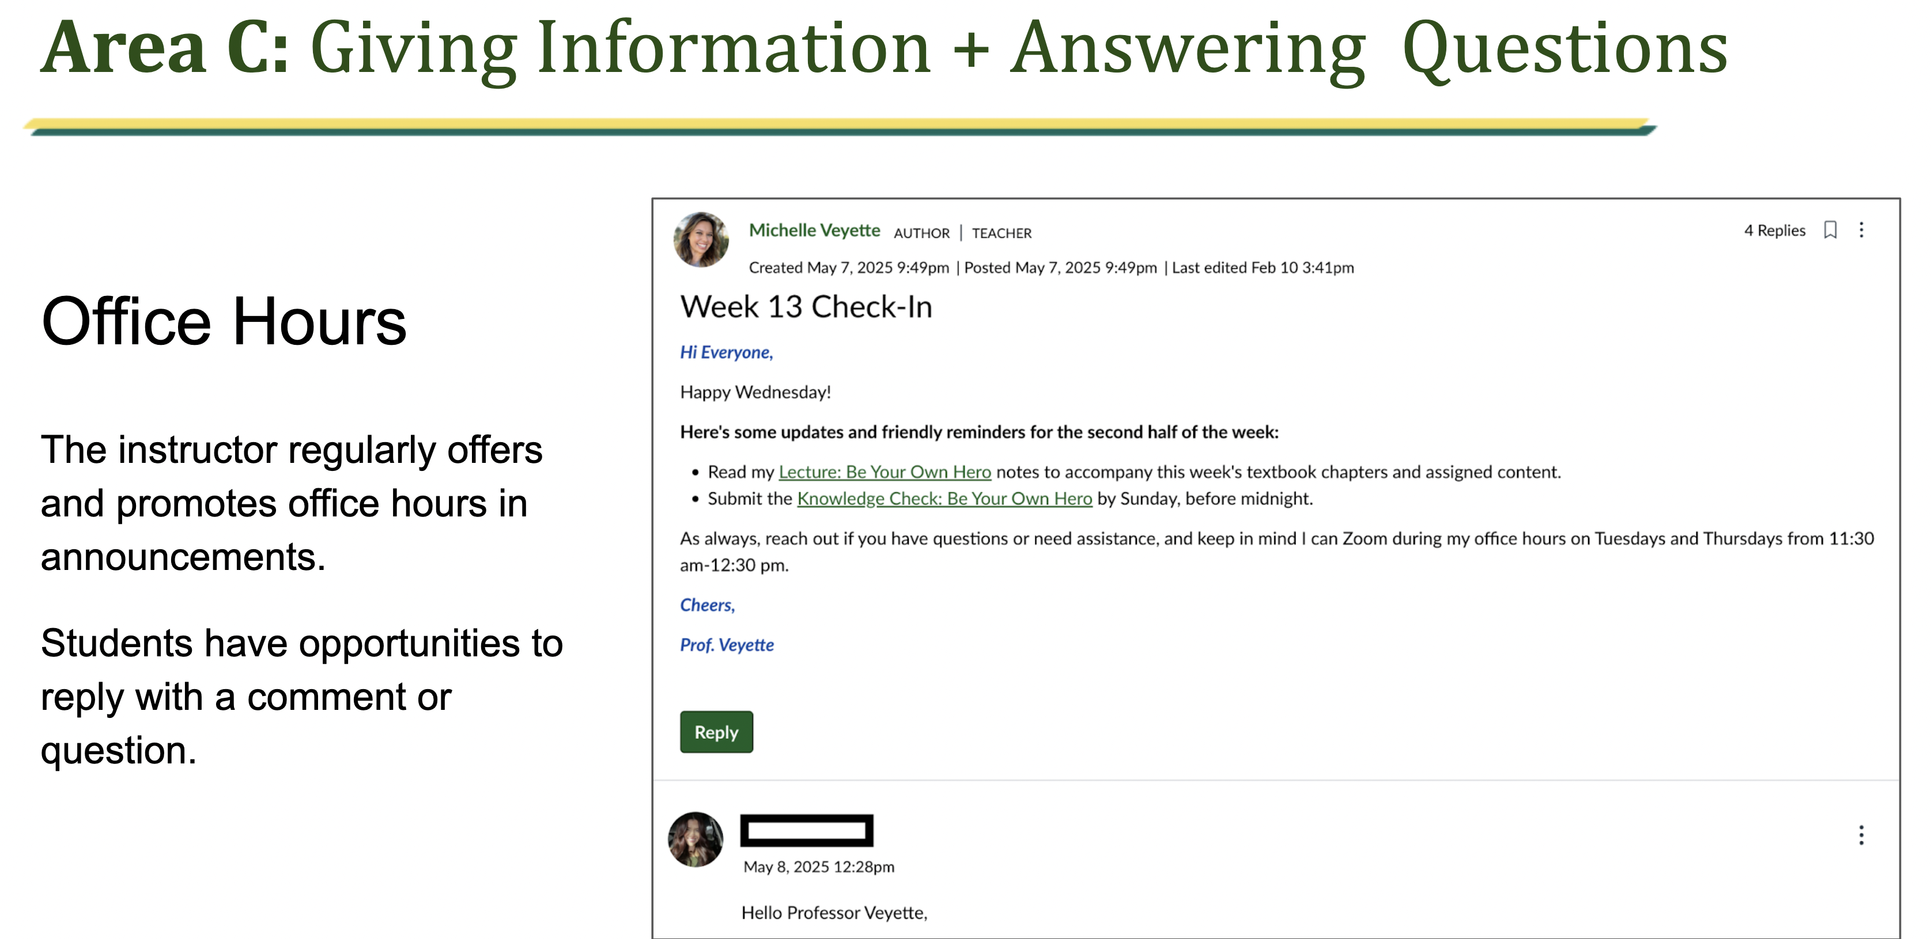

Area D
