Instructions for Posting Course Syllabus to myGWC
Cut and Paste Instructions
Please Note: If using a PDF file, please see PDF instruction

Please login to your myGWC account.
Click on the Faculty Tab to get access to all your assigned courses.
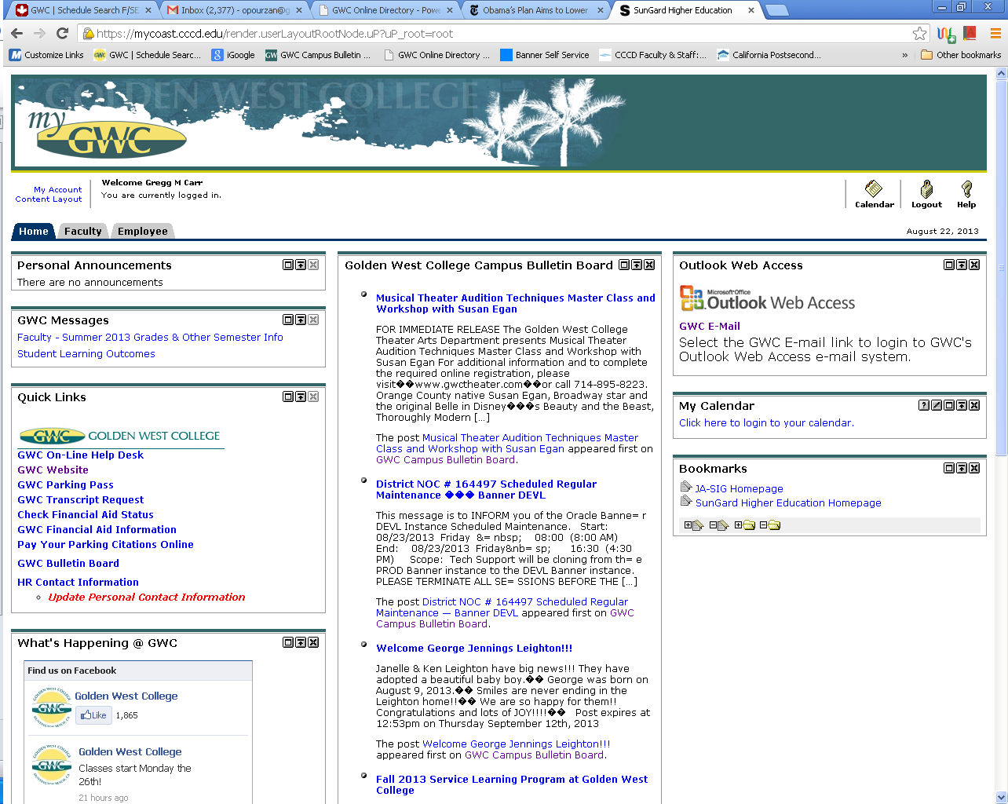

In the Faculty dashboard channel, choose the course for which you would like to load a syllabus. Then click on the syllabus icon as highlighted with the circle and arrow below:
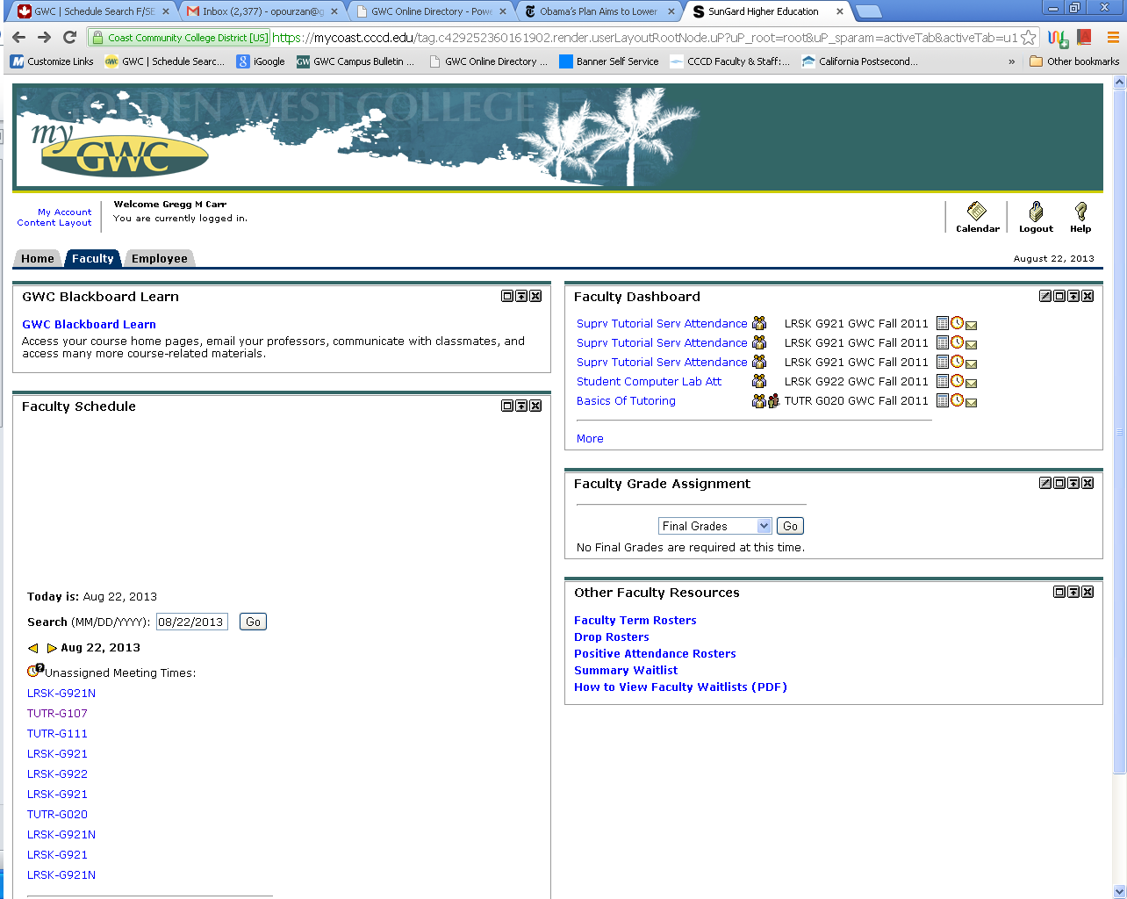

The Syllabus icon, will bring up the following screen.
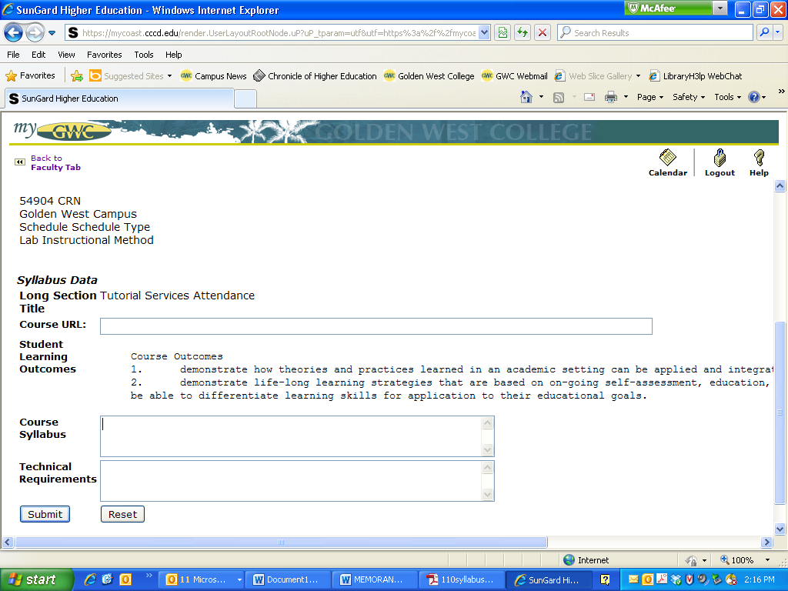

Leave the browser window as is, and open the document that contains your course syllabus. Copy the content from your syllabus and paste it into the myGWC Course Syllabus field.
A course syllabus shall at minimum include:
- Course Name and Number
- Instructor Name
- Office Hours (if applicable)
- Instructor Contact Information
- Student Learning Outcomes (NOTE: Include your official course Student Learning Outcomes as they appear in the Course Outline of Record (COR). If you are unsure about the official Student Learning Outcomes, please contact your department chair or your department Student Learning Outcome Coordinator (SLOC). The Student Learning Outcomes category must be clearly labeled in your syllabus.)

The image below shows an example of how your syllabus will appear in this field.
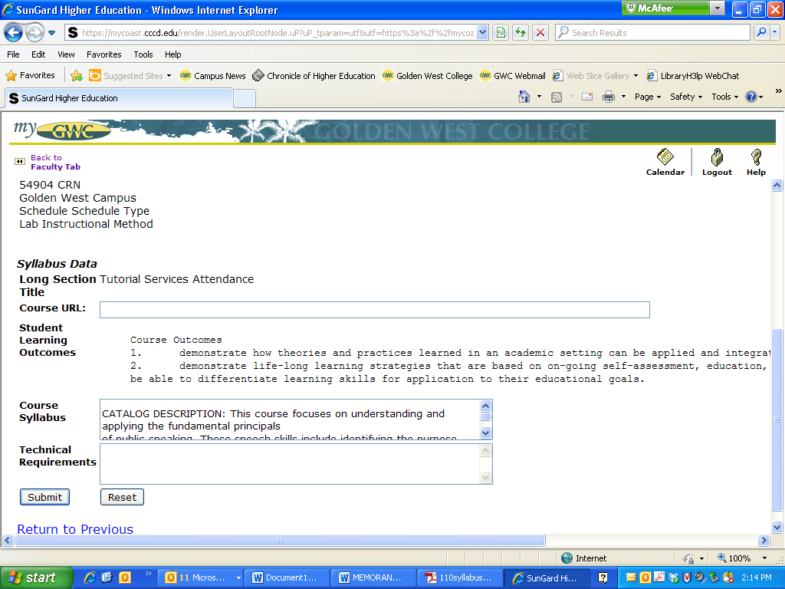

Once you see your course syllabus content successfully copied into the “Course Syllabus” field, press the Submit button at the bottom of the screen to finish this action.

Congratulations! Please repeat this process for each of your assigned courses.

